**Adaptive Business Intelligence**

**ISCG 8043**

**Semester 2**

**August 2020**



**Assignment-1**

**Early Childhood Education Centre**

**Prepared By: Priya Payyadi Surendran**

**ID:1533656**

**Supervisor: Miss Natt Nuntalid**

**Declaration:” Wherever this assignment draws on the work of others, such sources are clearly acknowledged.”**

ABSTRACT

A detailed exploration of Early Childhood Education Centres (ECE) in New Zealand has been conducted. ECE provide care and education for children under 6 years of age and is not compulsory. Some form of early education is given to almost 95% of children in New Zealand. Many government bodies have set national curriculum and ensures standards and teacher quality are sustained in each Early Education Centre. For the same reason a lot of information needs to be stored, processed and transferred. This information can be used for budgetary analysis forecasting as well as increasing the business profit. Adaptive Business Intelligence (ABI) concept is employed to explore more on increasing the profitability, a proper budgetary analysis to decrease the cost, improving customer relationship management and reduction of risk. A detailed explanation of how these data flow ,business responsibilities and various roles and which Adaptive Business Intelligence techniques can be implemented to achieve them.

Keywords: ECE, ABI

Table of Contents

SECTION 1 3

Introduction 3

Summary and Background of Early Childhood Centre 3

Benefits of Early Childhood Centre 3

Different Kinds of Early Learning Services. 4

SECTION 2 7

Business Application 7

Centre Based Early Childhood services 8

Functioning of Early Childhood Centres 9

Advantages of using ABI techniques on Early Childhood Centre 13

Disadvantages of using ABI techniques on Early Childhood Centre 14

SECTION 3 15

Concept and Theory 15

Forecasting 15

Time Series Forecasting 16

Single Exponential Smoothing 16

Double Exponential Smoothing 16

Simple Moving Average 16

Mean Absolute Percentage Error 17

Advantage of Time Series Forecasting 17

Disadvantage of Time Series Forecasting 17

Limitations of Time Series Forecasting 17

SECTION 4 18

Future Development 18

Conclusion 18

References 19

# SECTION 1

## Introduction

### Summary and Background of Early Childhood Centre

Babies are amazing and they start learning right from birth. Early learning starts from parents as they are child’s first teacher and early learning is the first step to a great future. Early learning helps a child to be curious and confident and prepares them in a better way for higher education. A child learns from the person whom they talks or plays with, everything seen or felt. Early learning services and kohanga reo helps in building the early learning the child is already doing, and they are great investment for the child’s future. An ECE provides care and education for children below the age of 6 years. Even though it is not compulsory in New Zealand ,early learning services are encouraged since it’s good for child’s future. Over the past decade, the number of children joining the Early learning services have increased and children between 3 to 5 years attend the services for 20 to 22 hours per week. Children born overseas can also go to an ECE in New Zealand (Practical information about education for parents and carers, 2020).



### Benefits of Early Childhood Centre

ECE help children to learn important skills which will aid them to become stronger, successful and happy in their future. It also helps to make new friends, share and cooperate. Child will be able to listen to others and can communicate their own ideas well. It helps to become independent and take responsibilities. ECE support children to become resilient in order to manage difficult situations, become lifelong learners and to do better at schools.

Parents value early learning as they provide experience and chance to explore new things, opportunities for both child and parent to meet new people and get along with everyone and show more involvement in the community. It also provides care for child when the parents are at work, or at home with younger kids or at college studying. ECE are friendly and fun, and parents and families are allowed in the centres to help child learn and grow. Thus, importance of early learning spread to the whole family and to the wider community as well (Practical information about education for parents and carers, 2020).



### Different Kinds of Early Learning Services.

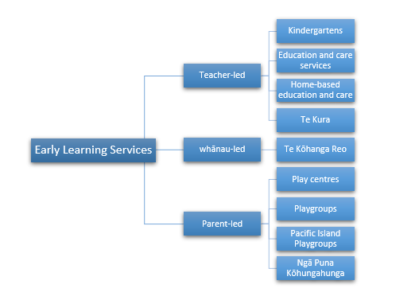

Figure 1:Different Early Learning Services

Teacher-led is licensed and 50% individuals who care and educate children must be certified and qualified as early learning service teachers. The standard kept by the government related to health and safety , property, education and care programmes and staff and management of the services. The teacher-led early learning services includes:

Kindergartens where children of age between 2 and 5 are accepted and are managed by a Kindergarten Association and all the staffs are cent percent qualified. They work closely with family of children and offer whole day care and education or part day sessions. Care and education services run flexible-hour or whole day activities for children from birth to 5 years.

It can be owned privately or owned by a community group. Home based care and education services provided for children from birth to 5 years and a maximum of 4 children in either at the child’s home or tutor’s home .

Te kura which is the correspondence school provides learning services for children between age of 3 and 5 years who cannot go to an early education centre.

Whānau-led or parent-led implies parents or the family are included in the caring and educating the child. These services highlights the need for the involvement of parents and family in the child’s life and they have more chance to learn further about parenting, developing social networks and boost the confidence level. The various learning services includes:



Te Kōhanga Reo provides a Māori environment for children from birth to 5 years.

Playcentres are run in cooperation with parents and family members. It accommodates children from birth to pre-school age.

They are part of a regional association for management and programme support which is managed by the New Zealand Playcentre Federation.

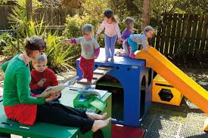Playgroups are operated by parents and family members and is a community based group. Sessions are held in community halls up to 4 hours per day.

The parents must attend the sessions along with the children. They are not licensed but certified and obtains information, support and training from the Ministry of Education. Pacific Island Playgroups are playgroups in pasifika culture and language. Ngā Puna Kōhungahunga are playgroups that focus on learning te reo Māori and tikanga.

Licensed ECE are required to follow the criteria and regulatory rules set out in the Licensing Criteria for Early Childhood Education and Care Services 2008 and Education(Early Childhood Services) Regulation 2008.



# SECTION 2

## Business Application

According to (Population, 2020),there were 61,460 children aged 4 and 61,500 aged 5 in New Zealand on 30 June 2019. Out of which 75% of 4 year aged children and 84% of 5 year aged children attended early childhood education for at least 10 hours a week on an average . This has increased since the June 2018 figures (Participation Intensity measures, 2020).

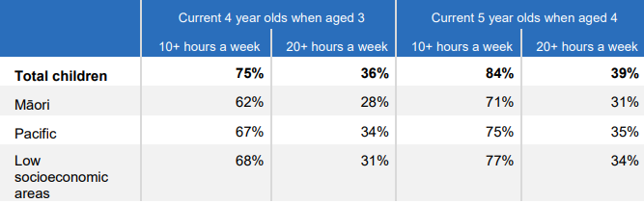

Figure 2:Participation intensity measure results, June 2019

The government announced $278.20 million towards restoration of the cent percent funding band for teacher-led early education services from the budget 2020 (Budget, 2020). Changes in family life like increased count of teenage parents, single parents, decrease in the involvement of extended families and rise in cost of living have brought the need for child care outside home. Not only the change in family life, the success of publicly funded programs had shown that high value early education interference can lead to improve opportunities for children at risk and eradicate poverty (Scope of ECE, 2020).The need for ECE will be always increasing and is a low risk business. The key form of government subsidy for the licensed ECE centres is ECE funding subsidy and is paid thrice a year . 20 hours ECE is another type of funding for 3, 4 and 5 year olds where cost is fully subsidised for at most 6 hours per child and 20 hours weekly. It is high rate of funding compared to ECE funding subsidy and is paid thrice a year to those centres that meet all the required parameters.

### Centre Based Early Childhood services

The example application related to ABI will be Centre Based Childhood services which is the teacher-led services discussed earlier. Roles and Responsibilities of a Centre Based Early Childhood services includes (Starting a centre-based ECE service, 2020):

**Service Provider**: An agency, body or an individual who runs the centre and is the owner of the license. Service provider is legally accountable for meeting the regulatory terms.

**Contact Person**: An individual chosen by the service provider for representing the organization . Person must act on behalf of service provider and must reside locally. Name of the Contact person will be exhibited on the certificate of license and must reply to the Ministry of Education as early as possible pertaining to issues with licensing.

**Person Responsible**: One or more person chosen by service provider and will be the prime responsible for daily education, support, safety and care of the children. Must manage all the adults providing care and education in the ECE and one person responsible for every 50 children.

**Lead Teacher**: Lead teaching person who ensures that the environment provides quality care and education that reflects the policies and legal requirements.

**Teacher**: A person who provides an exciting environment for children in a respectful and safe environment. Person must have either Bachelor of Teaching degree or graduate diploma of teaching.

**Administrator**: A person responsible for all aspects of the ECE. Administrator must manage the teaching staffs and provide conflict resolution. Administrator must take responsibility for business aspects like budgeting and program costs.

**Maintenance Team**: This team contains professional for all key areas like property maintenance, food and safety maintenance, first aid qualifications and over all cleanliness and management.

**Chef and kitchen assistant**: A person who will provide cooked meals for children in the centre.

The working hours of the centre in most of the cases are from 6:00am to 7:pm on all weekdays.

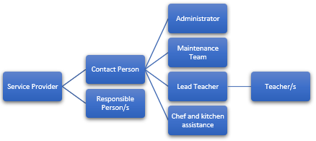

Figure 3: Structure of ECE

The income of the ECE is from the fees from the enrolled children classified under various categories like under two years, above two years, seasonal workshops, after school care etc. Average child care cost for ECE in New Zealand is $5.50 per hour. The ECE must try to fill the entire capacities and the staff ratio specified by the Ministry of Education also needs to be maintained. Enrolment fees and waiting list fees can be collected from the parents as well as additional hours of enrolment outside the 20 hours ECE (where 100% funding by the government ).

The expenses of the ECE business will be the cost incurred to pay the remunerations to the staffs employed, the maintenance expenses for the building, play area, property etc.

Thus, determining the actual cost per child is the main aim for the success of a business. The timely collection of fees and avoiding delay in fee payment from parents is a key factor for running the business with a profit apart from aiming at running the centres at full enrolment capacity. Regular monitoring of attendance of children, maintaining the premises, staff ratio, timely fee collection etc will keep the business in profit.

### Functioning of Early Childhood Centres

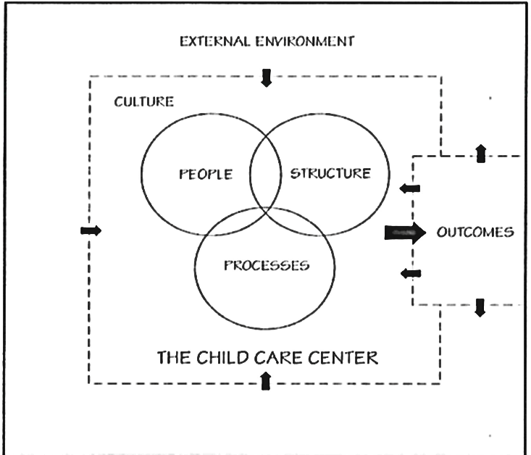

Business flow of the ECE and income generation and expenses tracked are explored in this section. The first and foremost step to start an ECE is to get a license from the Ministry of Education. A licensed ECE is eligible for government funding and there will be a regular review on the quality of the care and education provided by an Education Review Officer. After receiving the license and setting up the premises and facilities, the advertising of the new ECE is done through social medias, Newspaper, posters. When parents respond by enquiring, these data are collected and stored in the ECE Management Software. These data can be used for further procedures and follow ups. Once a child is registered and enrolled, the National Student Number (NSN) is allocated to the child during the first enrolment. The complete data regarding the child’s attendance in ECE is recorded against this NSN (NSNs, 2020).

Once the entire enrolment process is completed, the daily schedule process begins. Once the child’s attendance is marked for the day, the ECE management software tracks it till the child is signed out . This data is used weekly for fee collection from the parents. If the enrolled child is eligible for the Government’s 20 hours ECE, then the only fee for the additional hours of enrolment will be charged.

The daily schedule is categorised by the software for children under 2 years and above two years as per the Ministry of Education. Also, regarding the staff ratio where for children below two years, its 1:5 ratio and for above two years it is 1:10. This ratio must be maintained while preparing the roaster. The daily schedule itineraries like arrival, settling, free play, tea breaks, lunch, sleep and nappy time, group activities etc need to be charted by the ECE management software. Finally, when the child leaves the centre and signs out. Also, fee collection is done weekly and the bill will be generated by the ECE Management Software by calculating considering the factors like signed in time, sign out time and the subsidy eligibility. Payments for the other expenses incurred, remuneration to the staffs, roaster preparation, forecasting the income for next weeks, planning different events and activities on a rotation basis, Inventory management, menu management etc are the other tasks to be performed on weekly basis (C. Yi & Amburgey, 2011).

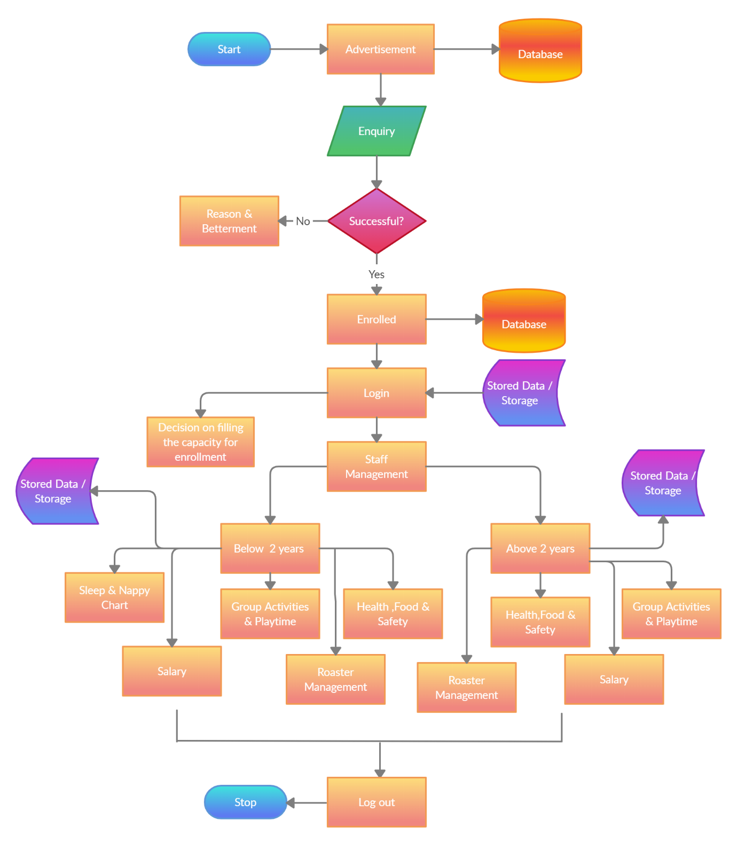

Figure 4:Flowchart of ECE Enrolment

### Advantages of using ABI techniques on Early Childhood Centre

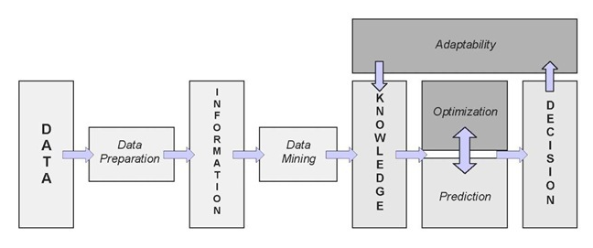

Figure 5:Adaptive Intelligence Business System

Each business has its oddities and the right Business Intelligence takes these oddities in to account and offers a customized complete solution. The benefits includes:

**Fast and accurate reporting:** Customized reports to monitor the key performance indicators. Reports use more relevant data and is generated in real time so that ECE can act quickly on daily operations.

**Valuable business insights:** Since ABI helps ECE understand what is working and what is not. Easy to set up an alert and ECE can manage staffs in a better way.

**Competitive Analysis:**  Forecasting, budgeting and planning are various competitive ways to stay ahead. ECE can forecast enrolment and income in efficient way.

**Better data quality:** ABI helps to collect data from various sources to get a proper picture of things happening with the ECE. ECE can thus identify the income and expense per child in a better way.

**Increased Operational Efficiency:** ABI integrates multiple data sources which helps with ECE’s overall organisation so that administrators and maintenance team can spend less time tracking down data and can focus on their short and long term goals.

ABI also helps to increase the revenue, by leveraging existing data to deliver apt data to stakeholders at the right time and improving their operations. ABI tools also analyses inefficiency and help expand margins by empowering ECE to develop better strategies to spent budget in a better way.

### Disadvantages of using ABI techniques on Early Childhood Centre

**Data Breaches:** The main concern is the risk of data leakage. ABI tools for ECE handles sensitive data like a child’s complete details including sign in and sign out time, so an issue in the process will expose it harming the child or staffs or the parents.

**High Prices:** ABI software can be expensive, and the initial cost is a barrier for small business like ECE. Opting for self-service ABI tools to avoid initial installation cost and time taken to implement it.

**Data Size, format and correctness:** Integrating data from different sources is beneficial in providing better analysis, but ABI systems may have trouble working across various platforms. The size of the data for and ECE is relatively small for an efficient analysis and the data apprehended may not be in correct format.

**Cheaper options:** Other cheaper options like Microsoft data store models etc are easily available in market.

# SECTION 3

## Concept and Theory

The major drawback of the existing system is the lack of proper prediction regarding the enrolments of children for the coming years which will make the income generation at stake. Also, this will make future planning like budget for ECE, staff management, resources etc difficult. The accuracy of this prediction is vital for ECE to be competitive in this area of business. As far an ECE is considered, revenue and expenditure budget analysis, administrative expenses, human resources like staff etc can be determined only if there is an excellent estimation of the number of children enrolled annually ( Q. Lavilles & B. Arcilla , 2012).

### Forecasting

Forecasting is an important requirement towards effective and efficient planning. Forecasting is predicting the accuracy of future using the information available like historical and future information which can impact the forecasts. Initial step is to decide on what to be forecasted, in our case it is the children enrolment numbers and details. The next is to decide the forecast horizon, for an ECE, forecast will be required two months in advance and this forecasting is done frequently. Once it is determined what forecast is required, it is important to collect data () on which the forecast will be based (Hyndman & Athanasopoulos, 2018). The information that can be collected includes:

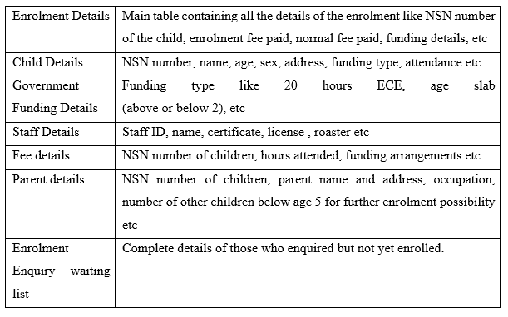

### Time Series Forecasting

Considering the ECE and enrolment pattern, Quantitative forecasting can be applied since information of the past is available and can be assumed that actions of past will continue in future as well. The quantitative forecasting used is Time series Forecasting (Abu Haris, Abdullah, Othman, & Abdul Rahman, 2014). When data is forecasted in time series, the goal is to evaluate how in future these sequences of observations will continue. The components of time series forecasting are level(base line value of the series),trend(increasing or decreasing behaviour of series over time), seasonality(repeating patterns over time) and noise(variability in observation that cannot be explained). The various models used to do forecasting for ECE are ( Q. Lavilles & B. Arcilla , 2012):

#### Single Exponential Smoothing

This model is used for inventory forecasting and in our case, we can employ it for employee forecasting in ECE. The equation is:,where is the weight of latest data(smoothing constant),is the actual data at time period t and forecast for period before current time period t . Actual data is provided with more weightage compared to old forecast data.

#### Double Exponential Smoothing

The formulas for double exponential smoothing are and where is the observed value at time t, is the forecast at time t, is the estimated trend at time t, is the first smoothing constant to smooth the observation and is the second smoothing constant for smoothing the trend.

Depending on implementation, the values of the models are initialised. The smoothing constant must be values of the range 0.0 to 1.0. When it is closer to 1.0, means more weight is given to new observation and when it is close to 0.0, more weight is given to old observation. The better value for smoothing constants is the one which gives least mean of the squared error

#### Simple Moving Average

The enrolment forecast can be calculated by average of actual enrolments (demands) from a specified number of prior periods. Each new forecast updates the enrolments in the prior periods and enrolment in the most recent time period is replaced by . Formula for order 4 is :

, where is the 4th value,is the 3rd value,is the 2nd value and is the 1st value to be forecasted.

#### Mean Absolute Percentage Error

Variances in actual and forecasted data can be compared to find the accuracy of the models used and is called model evaluation. Mean Absolute Percentage Error (MAPE) presents accurateness as percentage M=, where is actual and is forecasted values ( Q. Lavilles & B. Arcilla , 2012).

### Advantage of Time Series Forecasting

* Temporal effects: Effect of passing of time in the data used for problem solving and best way to deal is using time series forecasting.
* Allows to analyse patterns like seasonality, trend , irregularities, cycle.
* Data Cleaning: Time series forecasting makes it possible to find correct signal in dataset by filtering the noises and thus helps to remove outliers by applying average of the data.
* Understanding Data: Helps o understand data in a better way since the various models of time series forecasting helps to reveal the true meaning of data.
* Forecasting data over a period: It helps to forecast data over a period by increasing or decreasing the trend.

### Disadvantage of Time Series Forecasting

* Select independent variables for old and future values available.
* Revaluation and reconstruction of models as years pass due to the uncertainty surrounding enrolment forecasting.
* A short term forecasting can be done by assuming that independent variables will remain same over time as enrolment is sensitive to change in variables .

### Limitations of Time Series Forecasting

* Analysing the impact of single event: many events occur at one time and analysing impact of single event becomes difficult.
* Once a series has been established, the pattern will not be easy to understand as it uses mathematical equations and statistics.
* Even with considering seasonality, time series cannot forecast upcoming crisis.
* They perform poorly on long term forecasting as they depend on previous values.
* Most machine learning algorithms do not deal with time well and is difficult to understand.

# SECTION 4

## Future Development

Most accessible data is old time series data which can be used to understand baseline enrolment trends and season patterns. Demand forecast is generated by analysing time series data and by combining statistical approaches with machine learning. Demand anomalies like incremental and decremental demand are difficult to track and find the reason behind their occurrence and train the time series model accordingly. Nonetheless, to improve the accuracy, training the time series model is vital. The existing models can be integrated to other statistical models . Demand intelligence can provide perceptibility to these anomalies. A ranking system to recognize the demand factors, event categories to recognise what is causing the anomalies and labels to every event categorised can help to build hyper targeted models. With these new datasets, time series forecasting can be improved by training the models (Improved Time Series Forecasting, 2020).

## Conclusion

Business Intelligence is the technology for collecting ,integrating, analysing and presenting information related to the business in order to support better decision making. They provide old, present and future interpretations of business manoeuvres from information gathered in to data warehouse. In this report a quantitative forecasting known as time series forecasting is proposed as a business intelligence model for the Early Childhood Education Centres. A few models are explained in detail which can be applied and can contribute vital information in children enrolment area. For a better efficiency Demand Intelligence can be integrated with the existing models and improve the time series forecasting.

# References

Q. Lavilles , R., & B. Arcilla , M. (2012). Enrollment Forecasting for School Management System. *International Journal of Modeling and Optimization*, 563-566.

Abu Haris, N., Abdullah, M., Othman, A., & Abdul Rahman, F. (2014). Application of Forecasting Technique for Students Enrollment. *Knowledge Management International Conference (KMICe)*, (pp. 655-662). Malasia.

Boes , S., & Pflaumer , P. (2006). University student enrollment forecasts by analysis structural ratios using ARIMA-methods. *AStA - Advances in Statistical Analysis*, 253-271.

*Budget*. (2020, August 16). Retrieved from RNZ: https://www.rnz.co.nz/news/political/416915/government-reveals-278-point-2m-for-early-childhood-education-funding

C. Yi, J., & Amburgey, W. (2011). Using Business Intelligence. *International Journal of Business Intelligence Research*, 1-15.

Hyndman, R., & Athanasopoulos, G. (2018). *Forecasting: Principles and Practice.* Melbourne, Australia: OTexts.

*Improved Time Series Forecasting*. (2020, August 16). Retrieved from predicthq: https://www.predicthq.com/events/time-series?utm_campaign=&utm_term=%2Btimeseries%20%2Bforecast&utm_source=adwords&utm_medium=ppc&hsa_net=adwords&hsa_ver=3&hsa_grp=107688792361&hsa_tgt=kwd-924341995679&hsa_kw=%2Btimeseries%20%2Bforecast&hsa_cam=1052707408

*NSNs*. (2020, August 16). Retrieved from Education Services: https://services.education.govt.nz/eli/questions-and-answers/national-student-numbers-nsns/#:~:text=A%20national%20student%20number%20(NSN,the%20compulsory%20and%20tertiary%20sectors.

*Participation Intensity measures*. (2020, August 16). Retrieved from Education Counts: https://www.educationcounts.govt.nz/statistics/early-childhood-education/participation

*Population*. (2020, August 16). Retrieved from Stats NZ: https://www.stats.govt.nz/topics/population

*Practical information about education for parents and carers*. (2020, August 16). Retrieved from education.govt.nz: https://parents.education.govt.nz/early-learning/early-childhood-education/early-learning/

*Scope of ECE*. (2020, August 16). Retrieved from www.sagepub.com: https://www.sagepub.com/sites/default/files/upm-binaries/102108_Ch01_17.pdf

*Starting a centre-based ECE service*. (2020, August 16). Retrieved from Education.govt.nz: https://www.education.govt.nz/early-childhood/running-a-service/starting-a-service/starting-a-centre-based-ece-service/